# CHAPTER 5

# RESULTS

The starting page

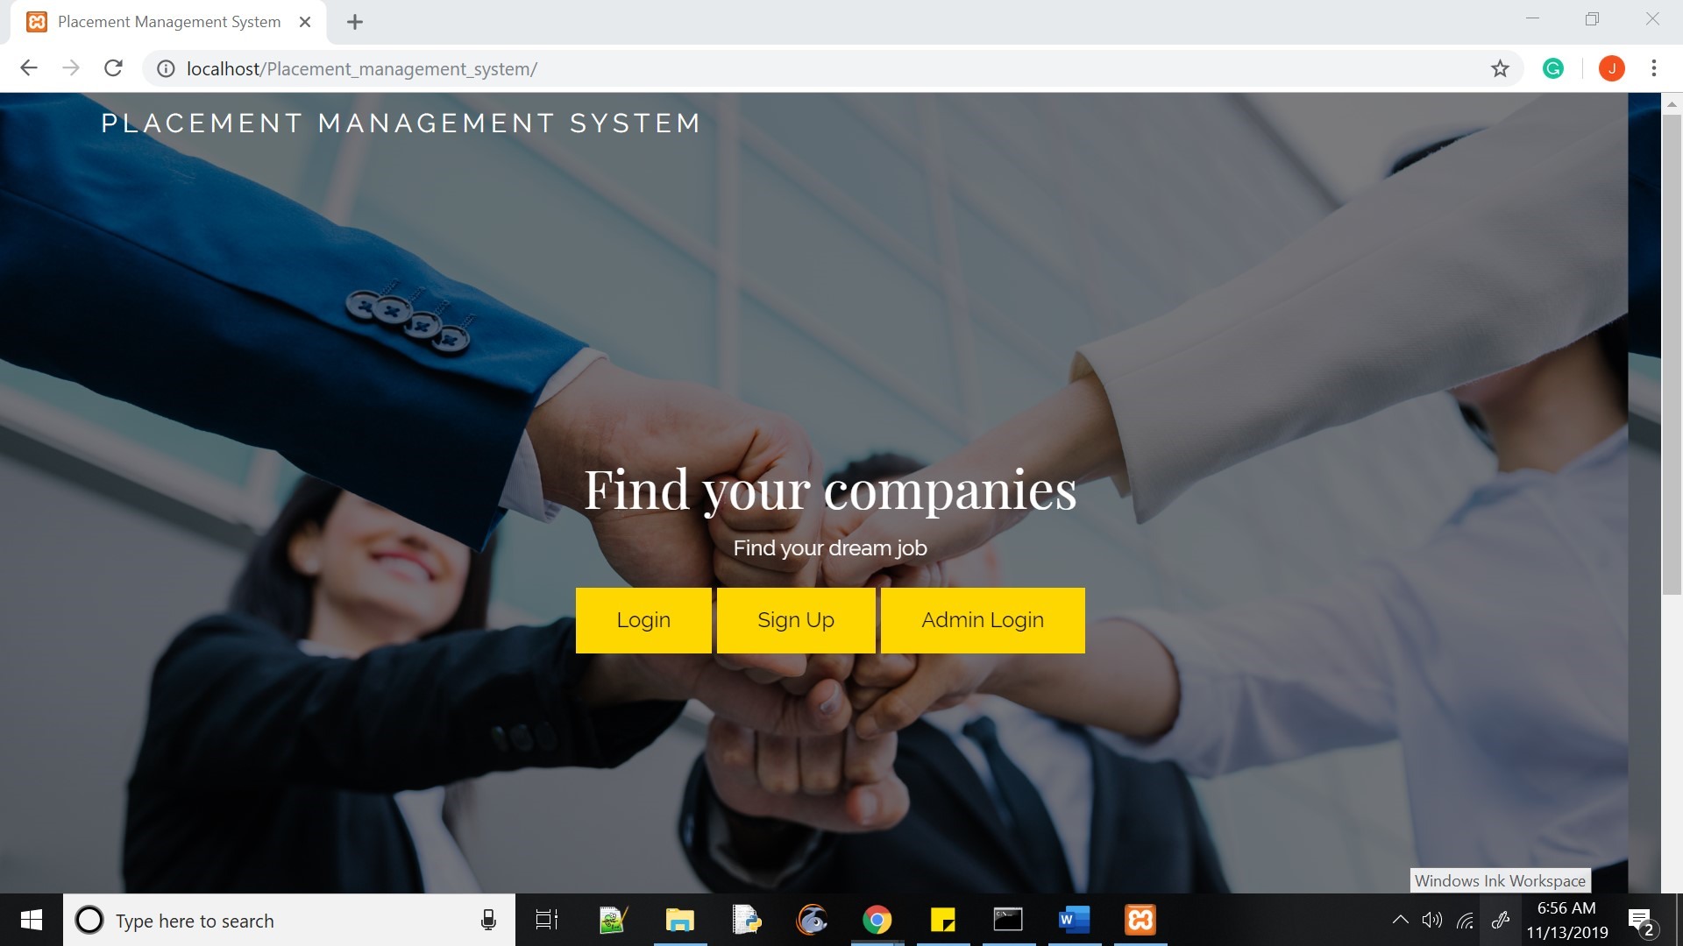

### FIGURE 5.1 HOME PAGE

The Admin login page where email and password are the required fields

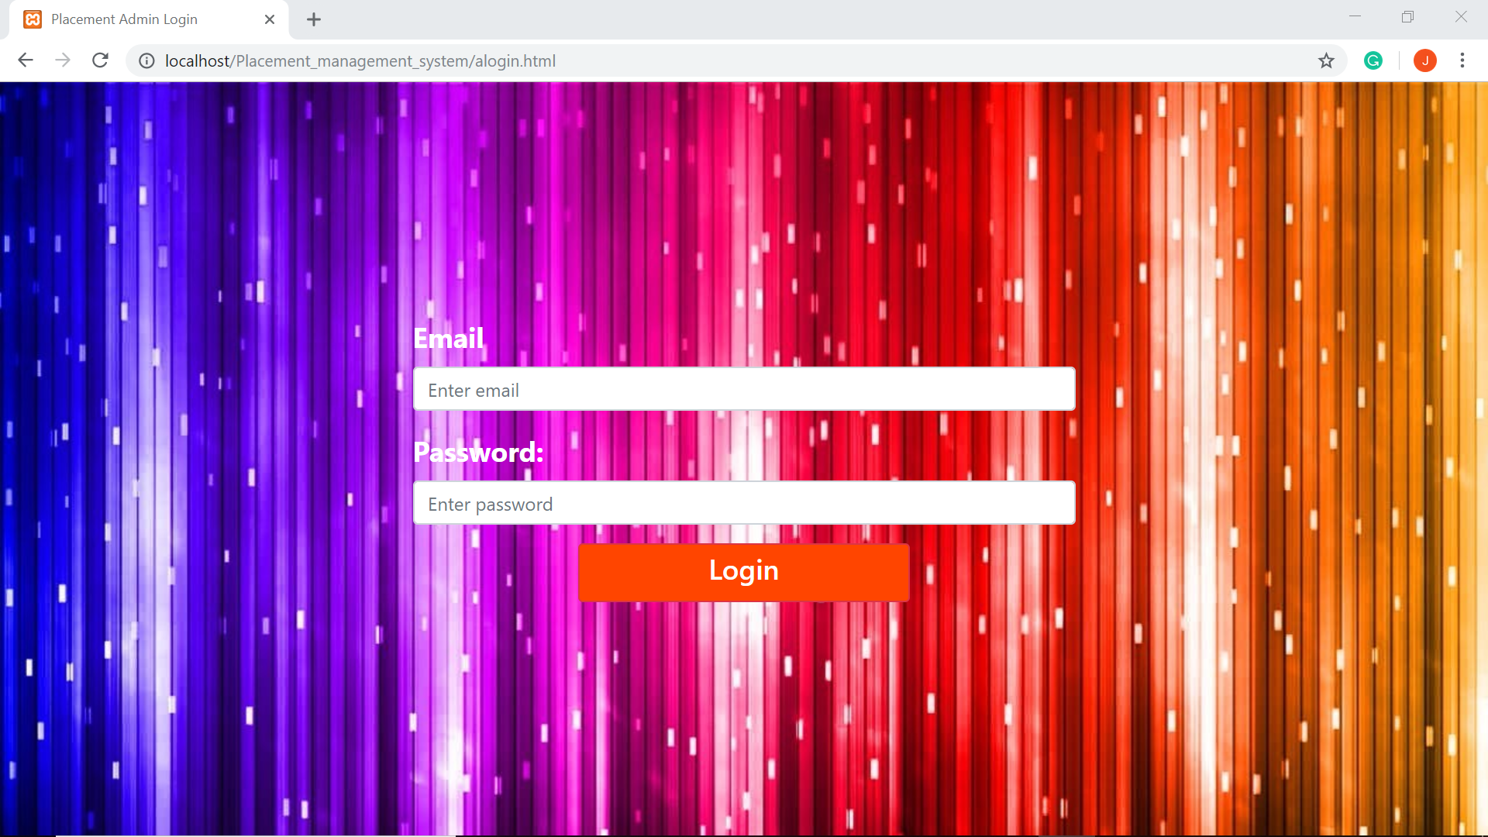

### FIGURE 5.2 ADMIN LOGIN PAGE

The User Login page where email and password are the required fields

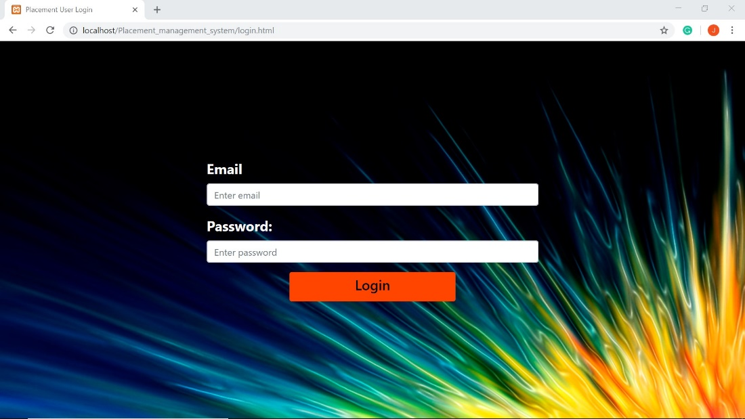

**FIGURE 5.3 USER LOGIN PAGE**

The admin’s landing page upon login

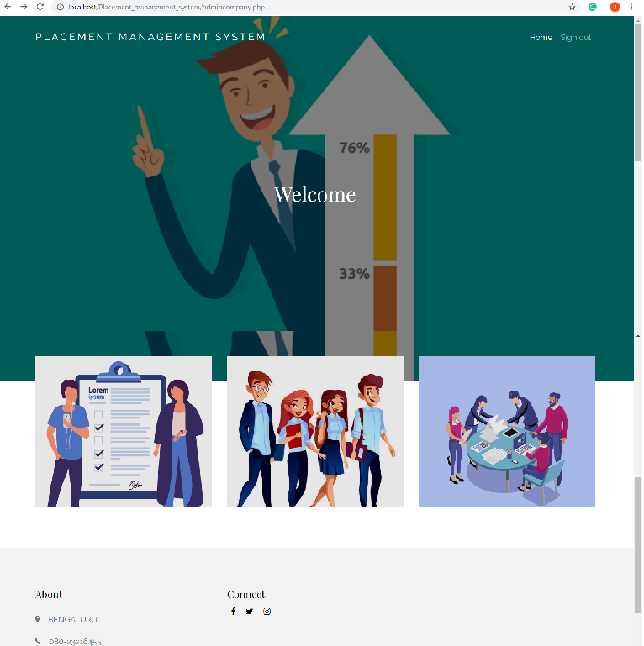

**FIGURE 5.4 ADMIN HOME PAGE**

Registered students view and option to remove registered students

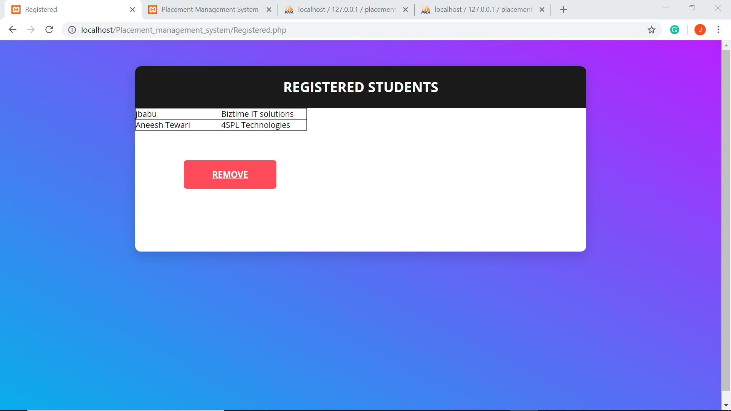

**FIGURE 5.5 ADMIN REGISTERED STUDENTS PAGE**

The student’s landing page upon login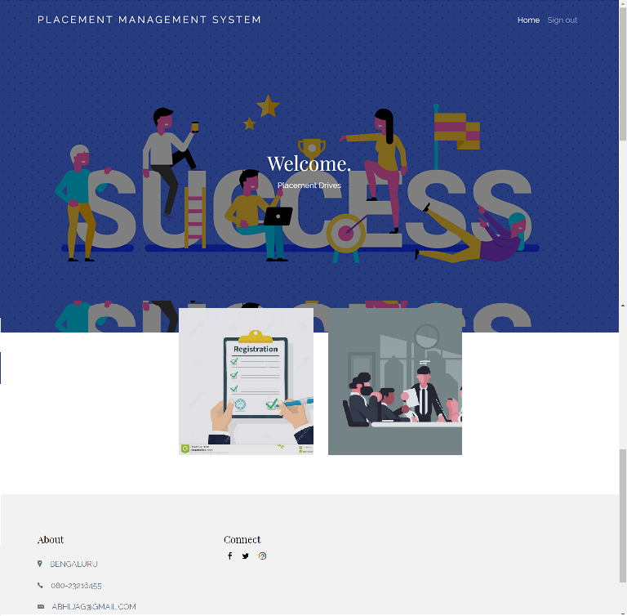

**FIGURE 5.6 STUDENT HOME PAGE**

The admin’s student list view with the option to add or remove students

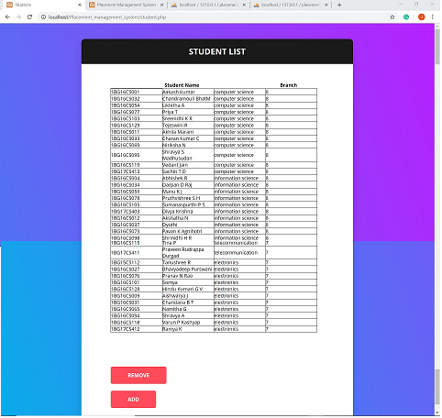

**FIGURE 5.7 ADMIN STUDENT LIST PAGE**

The admin’s company list view with options to remove and add companies

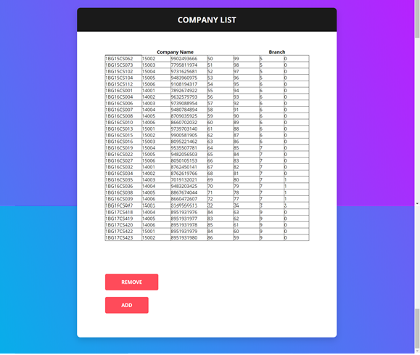

**FIGURE 5.8 ADMIN COMPANY** **LIST PAGE**

Students can register for companies through this page

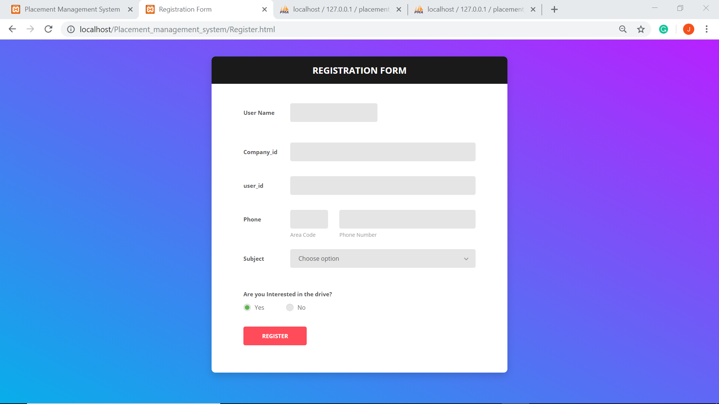

**FIGURE 5.9 STUDENT COMPANY REGISTRATION FORM**

The student company page, where he can see a list of companies and select which company to view details of

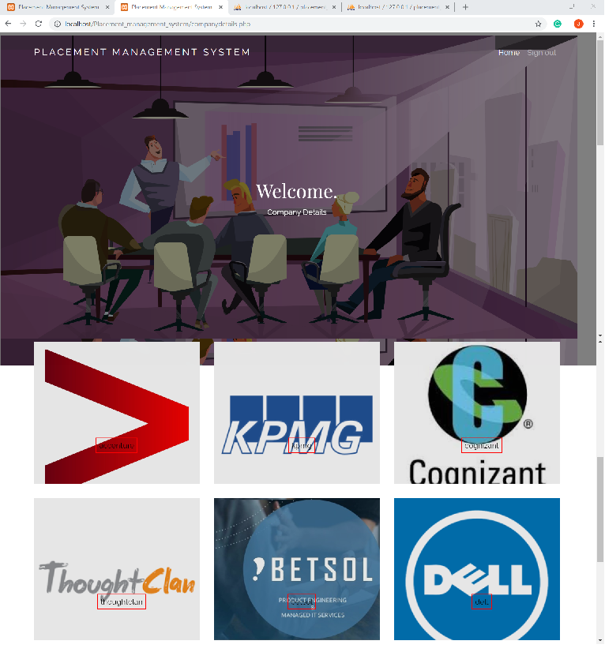

**FIGURE 5.10 STUDENT COMPANY PAGE**

The company details including alumni information and company’s share, revenue and net worth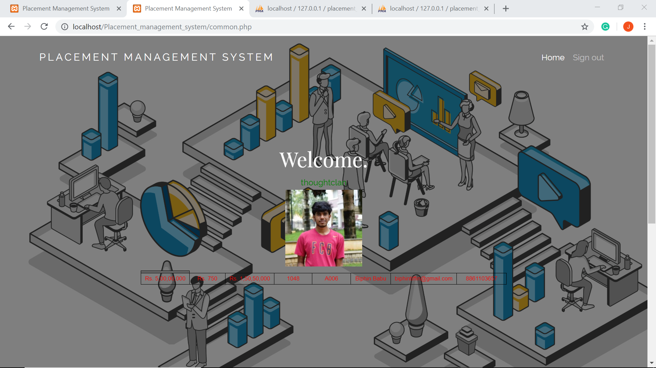

**FIGURE 5.11 STUDENT COMPANY DETAILS PAGE**

**CHAPTER 6**

# CONCLUSION

The development of the placement management system involved many phases. These problems, information needs, and activities were documented and later used as the basis for system design. The design phase was concerned primarily with the specification of the system elements in a manner that best met the needs. To implement this design, a computer program was then written in HTML, PHP, and CSS. It is hoped that the effective implementation of this software product would eliminate the many problems of the existing system.

“The Placement Management System” is designed and implemented using web Technology concepts which have become a widely accepted standard for developing web applications and websites.

Usage of Web Technology concepts, functions and primitives are well understood and henceforth can be applied for real-time applications by everyone.

This project is both informative and entertaining. This project provided an opportunity to learn the various concepts of the subject in detail and provided a platform to express creativity and imagination.

# CHAPTER 7

# FUTURE ENHANCEMENTS

This project/Website can have future enhancements that will make the website more popular and widely used.

This project can include enhancements such as enhance admin interface by adding more admin interactive features to personalize admin experience. Placement management can further be enhanced by adding many more events and services. Adding different methods of communication between the student, admin, alumni and company staff. Enabling a notification bar and linking the website functionalities to a mobile application can make the placement management system more functional.